Group 2

Module 11.1 Assignment

12/04/23

**Team Members**

Loreto Eclevia

Omar Johnson

Michael Richey

Francisco Sanchez

**Case Study:** Outland Adventures

**Report #1**

This report displays the total spent on ordering equipment and the total equipment sales made (through rentals and purchases). It tells us whether our customers are spending enough on our equipment for us to continue ordering this amount of equipment.

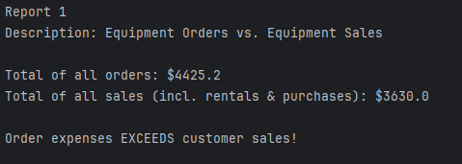

**Report #2**

This report displays the number of bookings for every location starting latest from now compared to closer to now. It tells us if any of our locations are seeing a “downward trend in booking”, and if we may need to scrap that location.

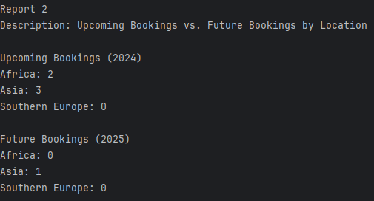

**Report #3**

This report displays all equipment items that are *over* five years old. It shows us equipment that is ‘too old’ and may need to be discarded. This equipment will likely not be modern or in good enough condition to sell to customers. Since it has been in inventory this whole time, it’s likely not selling at all.

